Our brainwave study, explained simply
A plain-language note on the BEED paper: what we did, what we found and why it matters. Written so it can be retold to friends, family or visitors at a poster.

What is this about?
Lots of researchers have been teaching computers to spot seizures from brainwave recordings. One newer, free-to-download collection of recordings, called BEED, quickly became popular. Several groups said their computer programs got 95 to 99 out of 100 right on it.
We asked a simple question: are those programs really learning about seizures, or are they picking up on quirks in how the file was put together? The short answer is: a lot of it is quirks.

What is EEG and what is epilepsy?
- Epilepsy is a condition where the brain sometimes has seizures: sudden bursts of unusual electrical activity. A seizure can cause shaking, staring or loss of awareness.
- EEG is a test that records the brain’s tiny electrical signals using small sensors placed on the head. The result is a set of wavy lines, one for each sensor.
- Why it matters: doctors read these wavy lines by eye. It is slow and needs an expert. A computer that could help would be very useful. Telling apart seizure types also matters, because it guides which treatment a patient gets.

What data did we use?
BEED stands for the Bangalore EEG Epilepsy Dataset. It is a single table of numbers with 8,000 rows. Each row holds 16 numbers. Each row is labelled as one of four groups, with 2,000 rows in each:
- Healthy people.
- Generalised seizures: seizures that involve the whole brain.
- Focal seizures: seizures that start in one part of the brain.
- Seizure-like events: episodes that come with behaviours such as blinking or staring.
According to its description, it was recorded at a neurological centre in Bangalore from 20 adults per group. The file does not say which row came from which person.

What did we try to do?
We wanted to build computer programs that learn from examples (called “models”) and can tell the four groups apart. We tried eleven different kinds, from very simple to more modern ones.
The usual way to check a model is like a school exam. You let it practise on most of the rows, then test it on rows it has not seen. But before doing that, we looked closely at the data itself. That is where things got interesting.

The big surprise we found
Surprise 1: the healthy rows were copied from somewhere else.
Every single one of the 2,000 “healthy” rows is an exact copy of a small piece of an older, well-known public collection called the Bonn data (healthy volunteers with their eyes closed). They come from a different centre, use just one sensor, and were recorded at about 174 readings per second. The seizure rows were recorded at 256 readings per second. None of the seizure rows matched the Bonn data.
Surprise 2: the rows do not mean the same thing in each group.
A healthy row is 16 readings in a row from one sensor, like 16 frames from one camera. A seizure row is one single moment seen by 16 sensors at once, like one frame from 16 cameras. So the computer can tell “healthy” from “seizure” just by noticing that the rows look different in shape, not by understanding brains.
Surprise 3: neighbouring seizure rows are almost twins.
Seizure rows are moments only about 4 thousandths of a second apart, taken one after another from a continuous recording. So each row looks almost exactly like the row before and after it. Each seizure group seems to be only about 8 seconds of recording in total.
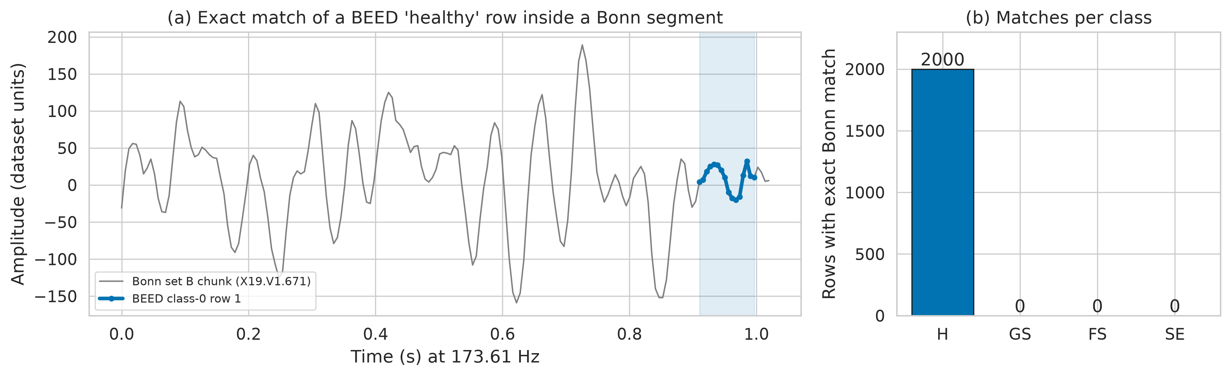
Picture: Left, the grey line is one second of brainwave from the older Bonn data. The blue dots are a “healthy” row from BEED, and they sit exactly on top of the grey line. Right, how many rows in each BEED group were exact copies: all 2,000 healthy rows (H), and none of the generalised (GS), focal (FS) or seizure-like event (SE) rows.

What happened when we tested fairly
Most earlier studies shuffled all the rows and picked some at random for the test. Because neighbouring seizure rows are near-twins, almost every test row had its twin in the practice set. It is like a student seeing near-copies of the exam questions the night before. In our check, for 88 to 95 out of every 100 seizure test rows, the closest practice row was literally its next-door neighbour.
So we also tested the fair way. We kept whole stretches of time apart: the last part of each seizure recording went into the test, with a small gap thrown away in between, so no near-twins could sneak across. The healthy rows were split by their original Bonn recording. Here is what happened:
- All four groups: with shuffled rows, the best model got about 99 out of 100 right. Tested fairly, the best got about 84 out of 100 right.
- Only the three seizure types: about 99 out of 100 with shuffled rows, but about 78 out of 100 when tested fairly.
- Healthy versus seizure: almost perfect either way. But a single simple check of how smooth a row looks got 997 out of 1,000 right on its own. That tells us it is spotting where the data came from, not a real sign of illness.
The order of which model was “best” also changed once we tested fairly. Models that simply look up the closest example did especially well with shuffled rows, and fell the most when tested fairly. In fair testing, the models were also more sure of themselves than they should have been.

The tiny fast model
We also wanted to know whether a model could be small enough to run on a small device, such as a wearable gadget. Our smallest good model:
- has about 11,000 internal numbers that it learns (small by modern standards);
- takes up about 43 kilobytes of memory, far less than a single phone photo;
- gives an answer in 0.08 milliseconds (thousandths of a second), much faster than new readings arrive (one every 3.9 thousandths of a second);
- got about 77 out of 100 right in fair testing, close to the best, much larger model (about 79 out of 100).
A larger model scored a little higher but took about 4.35 thousandths of a second per answer, which is too slow to keep up with the readings one at a time. So on this data, the limit is the data and the testing, not the size of the model.

What this means
- The very high scores reported on this file are mostly a result of how it was tested, not true skill.
- The healthy group should not be used to make medical claims, because it comes from a different source.
- Future studies on this file should keep stretches of time apart when testing, and say clearly how they tested.
- When we gave the computer short stretches of time (a quarter of a second) instead of single moments, it told the seizure types apart better (about 92 out of 100). But only 93 such stretches were available, so this is a hint, not proof. Longer recordings with patient labels would help most.

What we could not do (limits)
- The file does not say which person each row came from. So nobody can test whether a model works on a new patient. Our fair test only checks whether it works on a later moment of the same recordings.
- Because each seizure type seems to come from one short stretch of recording, the computer may partly be learning “which recording is this?” rather than “which seizure type is this?”.
- Our conclusions about how the seizure rows are laid out come from patterns in the numbers, not from official documentation.
- We only checked for copies against the Bonn data, not against other public collections.
- We kept our models small and did not spend a long time fine-tuning them.

One-minute summary to say out loud
“Doctors use EEG, which records the brain’s electrical signals, to diagnose epilepsy. A popular public file called BEED has been used to teach computers to spot seizures, with reported scores of up to 99 out of 100. We looked closely at the file and found two problems. First, all the ‘healthy’ examples were copied from an older collection recorded in a different way, so the computer can spot them by their shape alone. Second, the seizure examples are moments taken one after another, so neighbouring examples are near-twins. If you shuffle them for testing, it is like seeing the exam answers in advance. When we tested fairly, the score dropped from about 99 to about 84 out of 100, and for telling seizure types apart, to about 78. We also showed a tiny model, 43 kilobytes, can run fast enough for a small device. Our message: test fairly, and be careful with this file.”

Quick Q&A
Q: So did the earlier studies get it wrong?
A: Their numbers match ours when we test the same way they did. The issue is the testing method, not their sums. Shuffled rows let near-copies leak from practice into the test.
Q: Is 84 out of 100 a bad result?
A: Not bad, but it is the honest figure. It is also still a bit flattering, because the practice and test parts come from the same recordings.
Q: Can this be used in a hospital?
A: No. We could not test it on new patients, and the healthy group comes from a different source. It is a research step, not a medical tool.
Q: How did you know the healthy rows were copied?
A: We searched the older Bonn data for exact matches. All 2,000 healthy rows were found there, number for number. None of the seizure rows were.
Q: Why bother with a tiny model?
A: To show that seizure-spotting could one day run on a small wearable device without a big computer. Ours is about 43 kilobytes and answers in well under a thousandth of a second.
Q: What would make the data better?
A: Recordings that say which patient they came from, with longer stretches of signal, and healthy examples recorded in the same way as the seizure ones.

